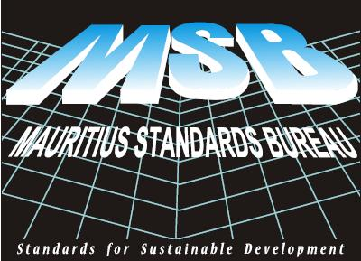

ISO 9001: 2015 QUALITY MANAGEMENT SYSTEMS IMPLEMENTER COURSE

Organized by: MAURITIUS STANDARDS BUREAU

Course Objective

The main objective of the course is to facilitate implementation of ISO 9001: 2015 and the following topics will be covered:

- Quality management definitions, concepts and guidelines;
- Interpretation of the clauses of the standard with a QMS implementation perspective;
- Understanding the requirements of ISO 9001:2015 within the context of the organization;
- Understanding the needs and expectations of interested parties;
- Understanding the scope of the quality management system and its processes;
- Applying the risk based approach/ methodology in the implementation of a QMS;
- Applying the process approach in the development of a QMS;
- Addressing documentation requirements for an effective QMS;
- Structuring a QMS for certification.

Fees per participant: Rs 15 000 (Inclusive of Course material + a copy of MS ISO 9001:2015 + Lunch)

Course recognition: MQA approved

Who should attend?

- Personnel/ consultants involved in the transitioning of the QMS to ISO 9001:2015;
- Personnel/ consultants involved in developing a QMS based on ISO 9001:2015;
- Members of a quality team;
- Internal and external auditors who will be auditing to ISO 9001:2015.

Venue: Conference room, Mauritius Standards Bureau, Moka

Date: 24, 26 & 27 March 2020

Course delivered by: Resource Persons from MSB

Contact Persons:
Mr. S Gungeea Email: sgungeea@msb.intnet.mu
Mr S P Kanaksabee Email: skanaksabee@msb.intnet.mu

Tel. (230) 433 3648 Fax. (230) 433 5051

