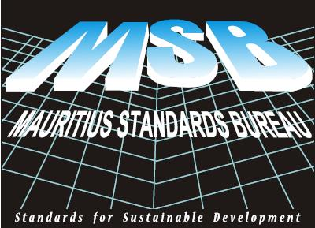
Jan 2015

Please tick ✓ the appropriate circle.

1. Please rank our current services according to your satisfaction level.

 | Not Satisfactory | Somewhat Satisfactory | Satisfactory | Very Satisfactory | Not applicable
Format of test/ calibration report - clarity | ○ | ○ | ○ | ○ | ○
Responsiveness to client | ○ | ○ | ○ | ○ | ○
Returning call of client | ○ | ○ | ○ | ○ | ○
Eagerness to help client | ○ | ○ | ○ | ○ | ○
Customer service in general | ○ | ○ | ○ | ○ | ○
Communication skills of officers | ○ | ○ | ○ | ○ | ○
Procedure of invoicing - payment | ○ | ○ | ○ | ○ | ○
Timely delivery of test report | ○ | ○ | ○ | ○ | ○
Certification Audit | ○ | ○ | ○ | ○ | ○

2. Kindly state the reasons for your organization to use the services at MSB.

Mandatory and controlled by regulators | ○
For in-house quality control and improvement | ○
Quality control upon request from clients | ○
To test new products before launching on market | ○
Other::………………………………………… | ○

3. Rank your agreement with the following statements:

 | Strongly  disagree |  |  | Strongly  agree
 | 1 | 2 | 3 |  | 4 | 5
MSB is very collaborative and always eager to help my company. | ○ | ○ | ○ |  | ○ | ○
The test/ calibration report form MSB is very reliable | ○ | ○ | ○ |  | ○ | ○
The testing or other fees charged by MSB are very competitive | ○ | ○ | ○ |  | ○ | ○
Thanks to MSB, I save money. | ○ | ○ | ○ |  | ○ | ○

4. Do you have any unmet need that you want MSB to address?
........…………………………………………………………………………………………………..
........…………………………………………………………………………………………………..

5. Will you recommend the services of MSB to others | Definitely | Probably | Probably not | Definitely not | Don't know
5. Will you recommend the services of MSB to others | 1 | 2 | 3 | 4 | 5
5. Will you recommend the services of MSB to others | ○ | ○ | ○ | ○ | ○

6. Are you aware that MSB has a new Training Section offering courses on quality related subjects?
Yes ○ No ○
6a Are you aware of the Mauricert Scheme/ Product Mark ?

Yes ○ No ○
6b Are you aware that MSB has a resource centre catering for reference materials on standards and standards related publications ?
Yes ○ No ○

7. Do you know that the website http://msb.intnet.mu contains resourceful information on the services of MSB? ? How can MSB improve its website further?
…………………………………………………………………………………………….……..........
…………………………………………………………………………………………….……..........
…………………………………………………………………………………………….……..........

8. Kindly define the activities of your company in one line.

…………………………………………………………………………………………….……..........

OPTIONAL
Name
Company
Address
Tel: |  | Fax: |  | Email

Thank you for replying to the questionnaire.

N Boojnan
Ag Marketing Officer
Mauritius Standards Bureau.
Villa Road, Moka.

